CLINTIX

BHUVANESWARI KAPULURU

FOUNDER @ CLINTIX

Executive Insights on Atliq Hardwares BY CLINTIX

By CLINTIX

[clyntix@gmail.com](mailto:clyntix@gmail.com)

+91 9490710484

**📊 Executive Insights on Atliq Hardware**

**1. Business Problem**

Atliq Hardware lacked structured reporting for executives, leading to delays in identifying sales opportunities, profit trends, and operational inefficiencies. Leadership decisions were slowed by reliance on static reports and manual effort.

**2. Objective**

To design an executive-level analytics solution that enables Atliq Hardware to:

* Answer critical business questions with data.
* Monitor KPIs across regions and customers.
* Improve decision-making with real-time insights.

**3. Technology Stack & Skills Applied**

* **Tools & Platforms**: Power BI, MySQL
* **Skills**: SQL Queries, Data Modeling, Dashboard Development, KPI Analysis
* **Methodology**: Agile for iterative dashboard delivery

**4. Solution Approach**

1. **Data Preparation** – Cleaned and structured sales and customer data for reporting.
2. **Business Questions** – Designed SQL queries to answer 10 critical business questions.
3. **Dashboard Development** – Built executive dashboards in Power BI with drill-through features.
4. **KPI Tracking** – Incorporated revenue, profit, and customer performance KPIs.

**5. Key Insights & Business Impact**

* Reduced manual reporting by **20%**.
* Provided leadership with **actionable insights** into sales and customer profitability.
* Improved **alignment between sales strategy and data-driven decisions**.

**6. Visuals / Screenshots**

*Placeholders for executive dashboard visuals (Revenue KPIs, Profit Trends, Sales by Region, Top Customers). 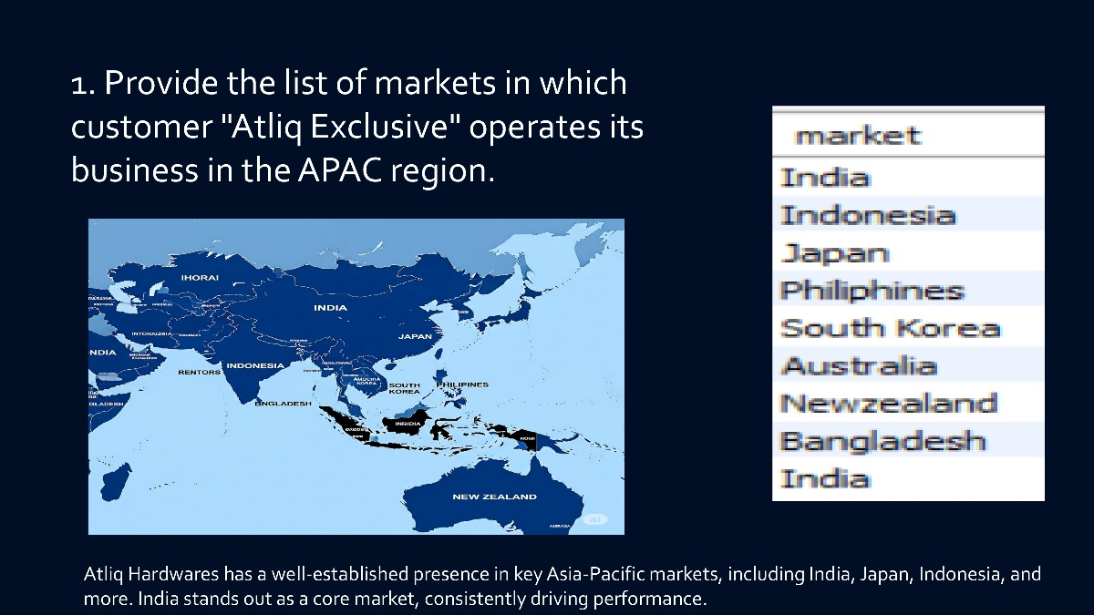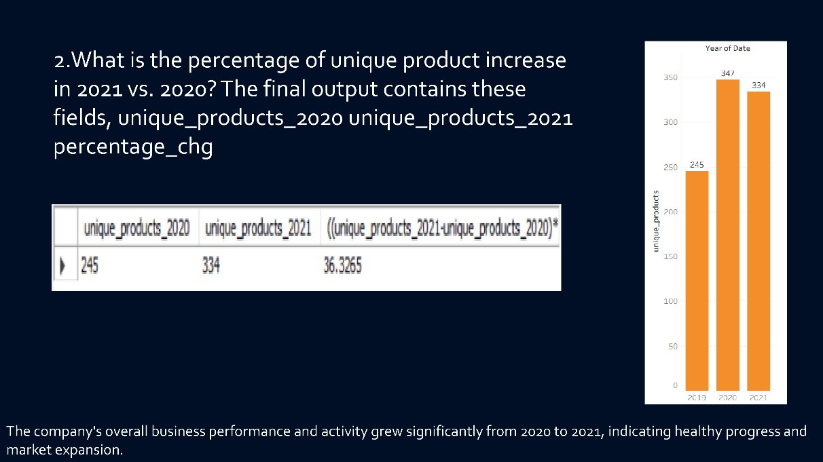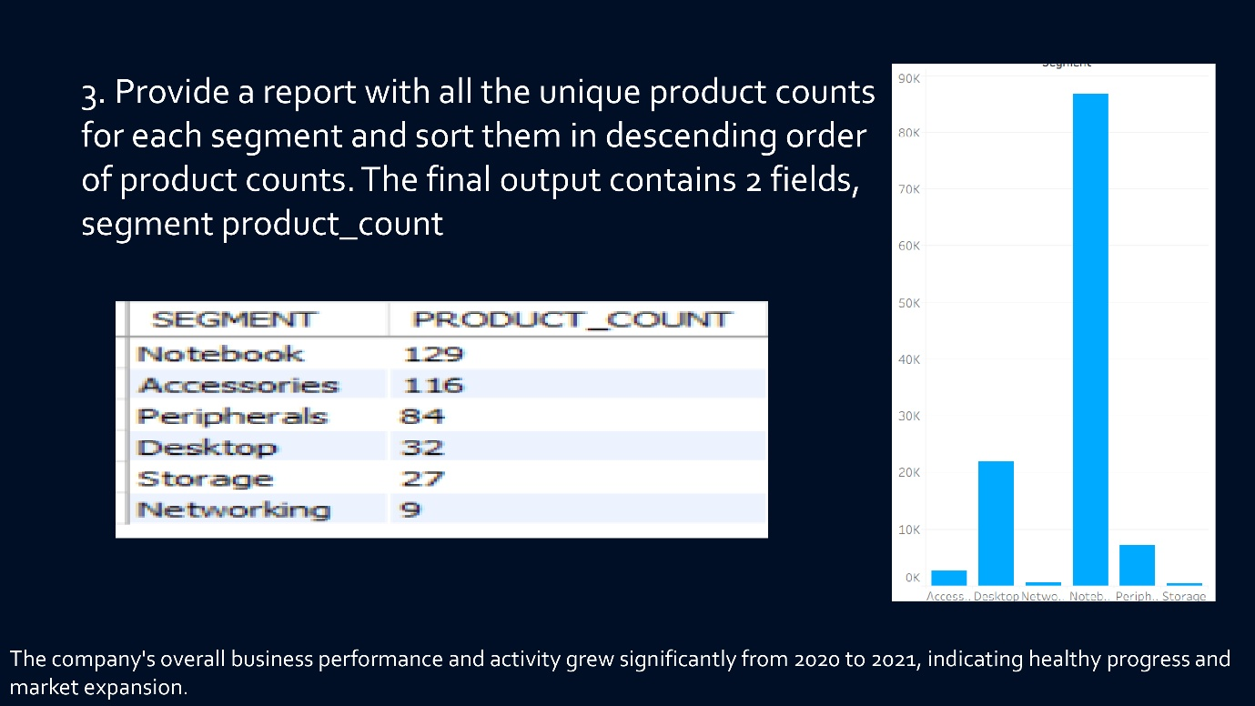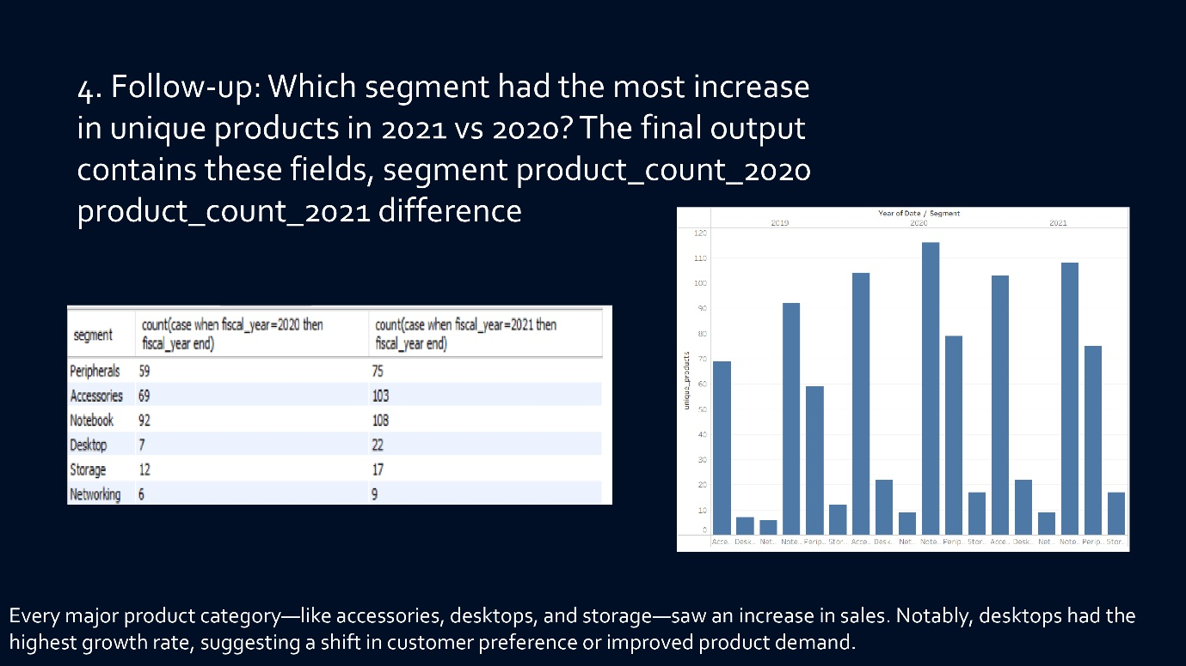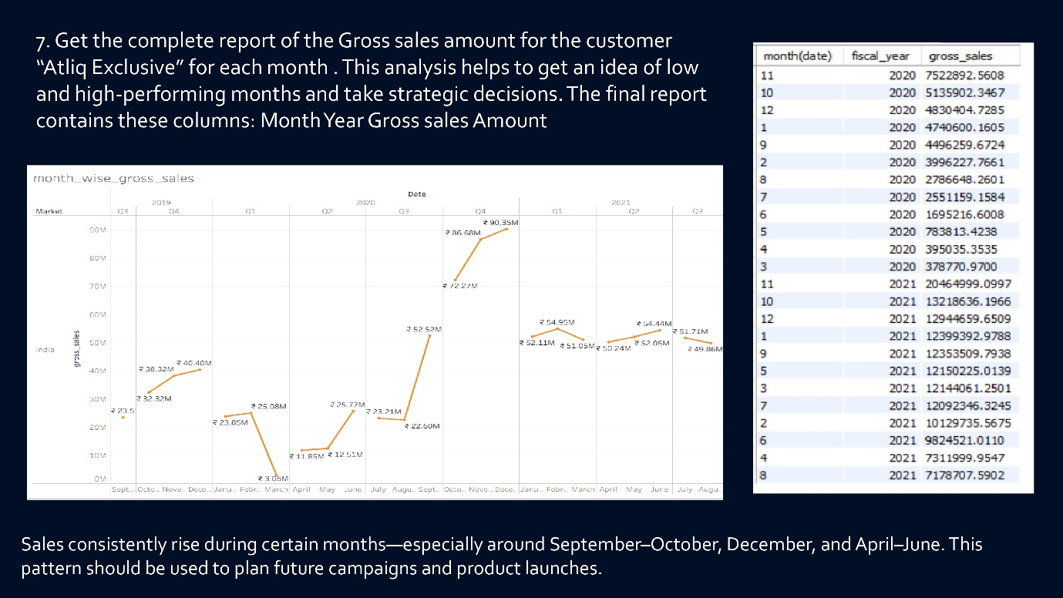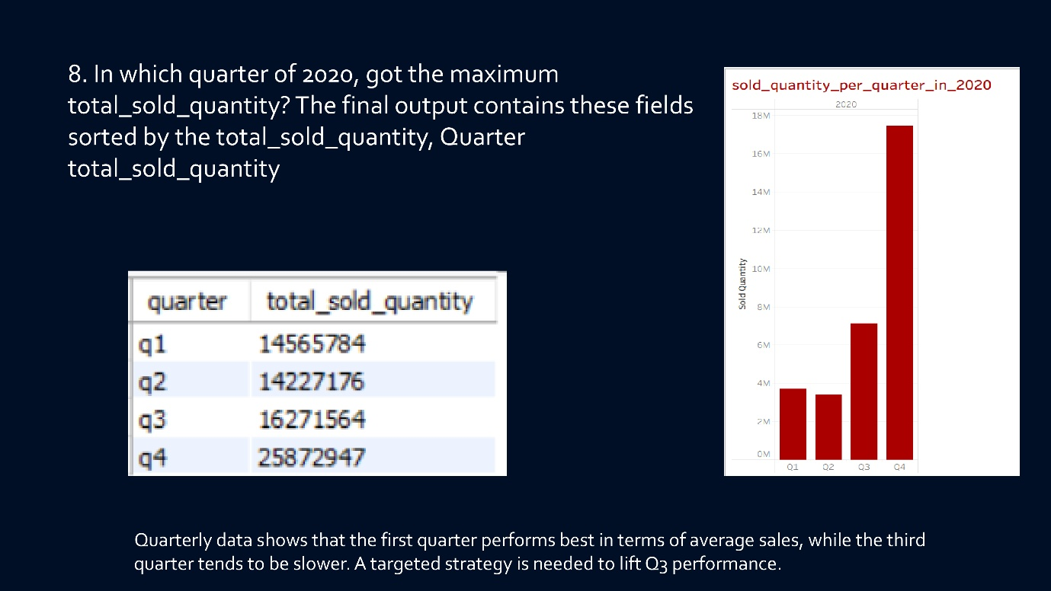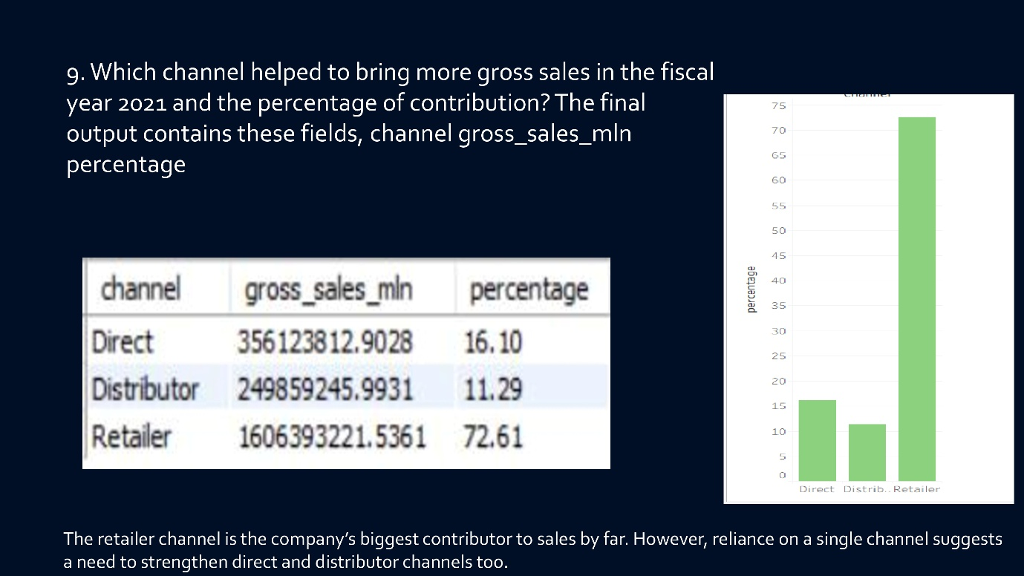*

**7. Reference Links**

* GitHub: [Repo](https://github.com/KapuluruBhuvaneswariVspdbct/EXECUTIVE-INSIGHTS-FOR-ATLIQ-HARDWARE)

**8. Conclusion**

The Atliq Hardware case study demonstrated how structured executive dashboards can empower leadership to make **faster, more effective strategic decisions**.